# CIA2503: Web Applications Development

# Lab/Activity 5

Course Learning Outcome: CLO3- Create interactive web pages using current standards-compliant client-side web technologies

Chapters: Chapter 4

Cognitive Levels: APPLY

Aim: The student should be able to:

* Construct programs modularly from smalls pieces of code called functions
* Define new functions
* Use additional global methods
* See how the visibility of identifiers is limited to specific regions of programs
* Use additional global methods
* See how visibility of identifiers is limited to specific regions in program
* Use the event object to get information about an event
* Learn the concept of events, event handlers and event bubbling
* Create and register event handlers that respond to mouse and keyboard events
* Use the event object to get information about an event
* Recognize and respond to many common events

Tools: Text Editor, Brackets, Notepad++, Web Browser

Document Revision Control:

# [MCQ- COGNITIVE LEVEL]

1. What will be the output of the following JavaScript code?

var a=225;

document.writeln(Math.sqrt(a));

a) 225

b) 15

c) Error

d) 2.5

1. What will be the output of the following JavaScript code?

var string2Num = parseInt("123xyz");

a) 123

b) 123xyz

c) Exception

d) NaN

1. What will be the output of the following JavaScript code?

var a=3.7;

var b=2;

a=ciel(a)

document.writeIn(a*b);

a) 6

b) 7.4

c) 7.5

d) 8

1. What will be the output of the following JavaScript code?

var add=new Function("num1","num2","return num1+num2");

document.writeln(add(2,5));

a) 2

b) 5

c) Error

d) 7

# Exercise 1- APPLY

Consider the code written in JavaScript. Complete the missing code that will calculate the average of 2 numbers using a function call. Define a function to calculate the average return a result. The function should accept 2 arguments /parameter values.

|  |  |
| --- | --- |
| <html>  <head>  <script>  var startProgram = function()  {  var x = 55.5;  var y = 40.8;  var average = calAverage(x, y);  document.getElementById("paragraph1").innerHTML= // *complete the missing codes….*  } //end startProgram function  function //complete the missing codes……………….  {    *complete the missing codes……….*  }  </script>  </head>    <body onLoad="startProgram();">Java Script Calculator<BR>    <p id="paragraph1">  This content will be replaced.  </body>  </html> | |
| Exercise 2- APPLY Write a JavaScript program to calculate the product of two numbers and then return and display the result. Your program should call a function which will multiply the two numbers together before returning a result. The function should receive 2 parameter values. | |
|  | |

# Exercise 3 - APPLY

Update the code in Exercise 2 so that the user can enter the 2 numbers into a window prompt to make the program more dynamic.

# Exercise 4 - APPLY

Complete the html program which will display your name after clicking the button as shown. A prompt box should allow the user to enter his/her name. Fill in the missing code which makes use of an event.

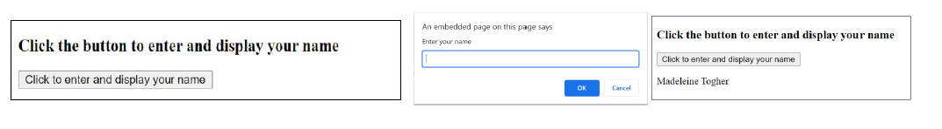

<!DOCTYPE html>

<html>

<body>

<h3>Click the button to enter and display your name</h3>

<button  **..*missing codes…..*** >Click to enter and display your name</button>

<script>

function showName() {

var name = ..***missing codes………….***

document.getElementById(..***missing codes………..***

}

</script>

<p id="demo"></p>

</body>

</html>

|  |
| --- |
|  |

Exercise 5 – APPLY - Difficult

Create a JavaScript program which will present a message if the text is selected as shown below. Use the event called **“onselect”**. When the user selects the piece of text in the text box, an event will be triggered/handled which will then call a function which will print out a message to the screen.

